LiveVault and Classic Salesforce
Customer Support Web Interface

The new LiveVault and Classic Salesforce Customer Support Web Interface has the following functions
- A support ticketing system for opening, editing and closing cases
- A knowledgebase
- A way to review case workload and history

How to access - https://livevault.custhelp.com/
Your login is your email address from Salesforce. As an existing customer you should already know this if you have already opened cases through email / Salesforce. Note a customer cannot setup their account to this site. If you do not exist in Salesforce you will not be able to access the site. To setup a contact in Salesforce you must contact Support or Account Management first.

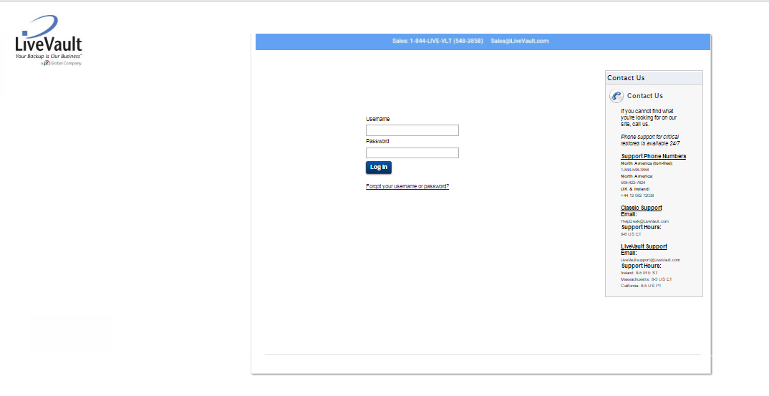

Password reset / Login issues

If you do not know your password or username, you should click on the link on the login page.
NOTE – If this is the first time you are trying to access the system you will have to use the Forgot password link to get your initial password to access the site.
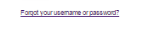
Then insert the appropriate information in the field for which you want to retrieve information for

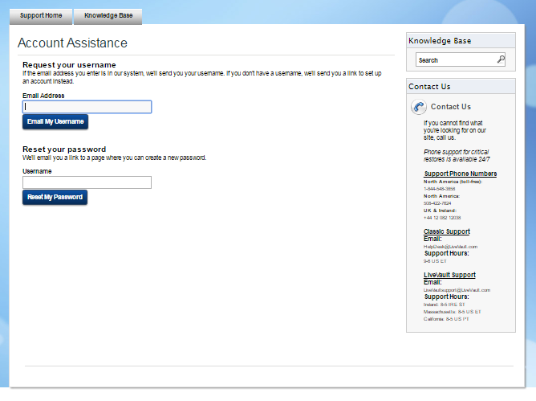

If you are resetting your password or retrieving your username after entering the correct information you will get the following responses

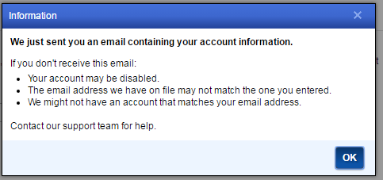

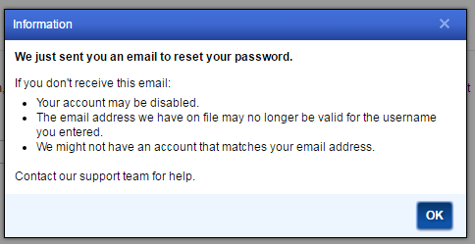

Once logged in you will see the following web page.

NOTE - The customer’s login is filtered to show a web page that is based on the product or products they use. If they use both LiveVault and Classic they will see content for both products.
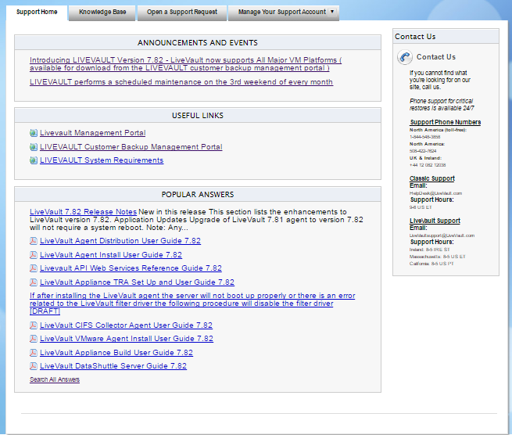

The landing page includes the following web pages

Support - the default view
Has 4 sections – Announcements, Useful Links, Knowledgebase, Contact info
Knowledgebase
Links to backend knowledgebase. Here you can search for solutions, look at recommended articles and see what solutions and documentation that are most commonly being accessed
Announcements, Useful Links, and Contact Info are straightforward and will be changed periodically based on need and function.

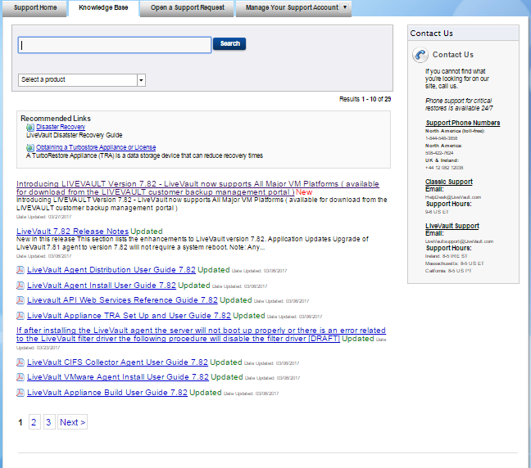
Open a Support Request
Used to open a support request. In addition to entering a description and a subject you must select a product. There is also an option to attach a file for which there is a 10 MB limit.
When a case gets created the Salesforce case number will be sent back to the Web interface within seconds.
If a case gets created in Salesforce the case will be sent to the Web interface and can then be managed from there.
Any field that is changed or edited in Salesforce that is mapped to the Web interface will be updated. For instance if you change a status in Salesforce it will be updated in the Web interface.
The thread that you will see in the Web interface will show the entire text of the thread with breaks showing from Support or from Customer

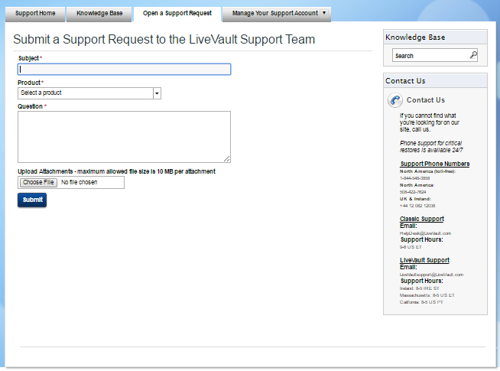
Manage your Support Account
Used to search, manage, sort, view, and edit cases. You can filter the view for just your cases or all cases for that account based on any status used by Salesforce. NOTE there is a status called Case in Queue. This status is created by Inbound Message Received in Salesforce or a case that gets reopened.

On this page you can also
Go to the change your password page
View the How to Contact Support
Notifications – these would be links to KB articles that we have updated that you have previously accessed.

